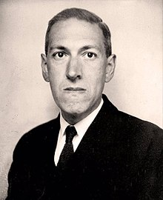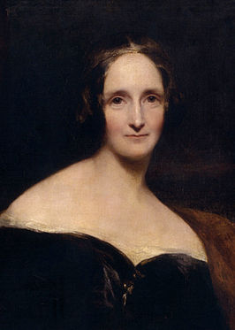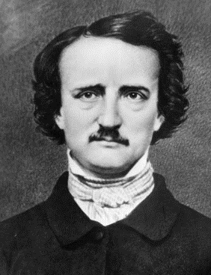

Herbert George Wells

Robert E. Howard

H. P. Lovecraft

Friedrich Nietzsche

John Keats

Thomas de Quincey

Lord Byron

John Milton

Mary Wollestonecraft

S. T. Coleridge

William Godwin

Edgar Allen Poe

Mary Shelley